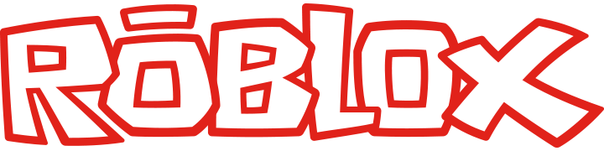

Employee Referral Policy
Thank you for recommending a candidate! Employee referrals are one of our greatest sources of both candidates and hires, and we really appreciate your help in finding the best and brightest potential future ROBLOX employees. Research has shown, and our own experience supports, that new hires who come into a company through employee referrals are excellent contributors, stay at the company longer and are a more cost effective recruit. Thus, as part of our recruitment and selection process, we have implemented an employee referral program. The following rules apply.

ELIGIBILITY
Any ROBLOX employee is eligible to receive a referral bonus, with the exception of:
- The Recruiting Team
- The Leadership Team (C-Level)
- The Manager for placement on his or her own team.

GUIDELINES
- In order to be eligible for the bonus, you must know the candidate you are referring in a professional or personal capacity. You will not receive a referral bonus for simply referring names or forwarding resumes of people you do not know.
- Referral bonuses are not paid for the following:
  - Independent Contractors
    - However, if a candidate is referred for an independent contractor, and is converted to a regular, full-time employee at a later date, the original referrer is then eligible for a referral bonus.
  - Interns
- In the event that the same candidate is referred by more than one employee, the date of the earliest referral will govern.

BONUS AMOUNTS AND PAYMENTS
- Referral bonuses are as follows:
  - $1000 for onsite interview
  - $5000 for candidates who get hired (paid after first day of employment)
- Please note that this bonus is subject to regular payroll deductions required by law.

